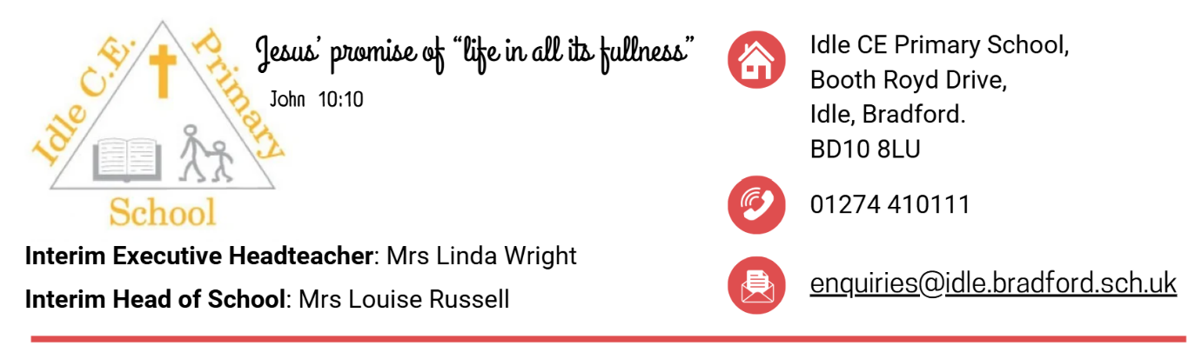

**Higher Level Teaching Assistant (HLTA)**

**Full time - Permanent**

**Salary: Band 8 (pt17 – pt22)**

**Start date:** As soon as possible

**Closing Date:** Wednesday 8th October 2025 **Interviews:** w/c 13th October 2025

**Join Our Caring and Ambitious School Community**

Idle C of E Primary School is seeking to appoint a dedicated, experienced, and enthusiastic Higher Level Teaching Assistant (HLTA) to join our committed staff team at a key point on our journey of improvement.

This is an exciting opportunity to make a real difference in a welcoming and inclusive school with a strong Christian ethos. We are proud of our nurturing environment, our high expectations, and our commitment to ensuring all pupils **thrive,** rise to new **challenges,** and are encouraged to be **brave** in their learning and personal development.

**Key Responsibilities:**

* Covering PPA time effectively across classes and Key Stages.
* Providing cover for classes to release teaching staff
* Providing high-quality small group and 1:1 support, both in and out of the classroom.
* Supporting the delivery of adaptive teaching to ensure all learners, including those with additional needs, can access the curriculum.
* Building positive and trusting relationships with children to support their academic, social, and emotional development.

|  |  |
| --- | --- |
| **The Ideal Candidate Will Have:** | **In Return, We Can Offer:** |
| ✅ Proven experience in a similar HLTA role, including PPA cover and intervention delivery. ✅ Experience supporting learning in Upper Key Stage 2. ✅ A positive, proactive, and nurturing approach to working with children. ✅ Excellent communication skills and the ability to work as part of a collaborative team. ✅ A commitment to the school’s Christian values and ethos. | * A welcoming and inclusive school community. * Enthusiastic and respectful children who enjoy learning. * A supportive staff team and committed leadership. * Opportunities for professional development and growth. * A school with a strong sense of purpose and community. |

**How to Apply:**

To apply, please download the application pack from our school website <https://www.idleprimaryschool.co.uk/vacancies> or contact the school office at [enquiries@idle.bradford.sch.uk](mailto:enquiries@idle.bradford.sch.uk)

Idle C of E Primary School is committed to safeguarding and promoting the welfare of children. The successful candidate will be subject to an enhanced DBS check and satisfactory references.